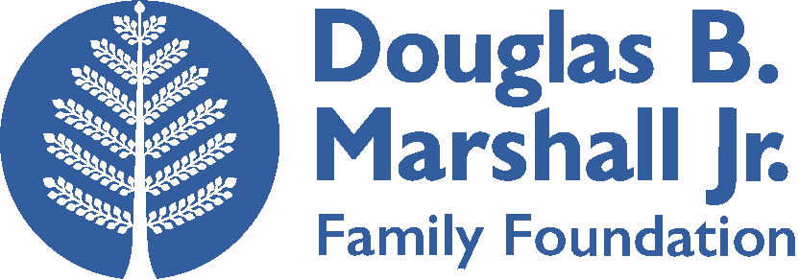

Grant Application Instructions

Grant applications are accepted on an invitation-only basis.

What we look for:

We are especially interested in funding projects that are:

  - Evidence based, with rigorous research showing that they improve educational outcomes
  - Cost-effective, so that the highest impact can be achieved at low cost
  - Scalable in the long term, even if programs are currently at small scale

We seek proposals for:
- Projects supported by evidence that they improve educational outcomes
- Projects that will contribute to the evidence base on what works to improve educational outcomes
- Applications that have clearly stated goals, with a credible plan for monitoring progress and evaluating impact, where appropriate
- Projects for which the budget is commensurate with the goals and activities
- Organizations and projects with strong leadership and management teams

These criteria serve as general guidelines, and we may make exceptions. All our funding decisions are made on a case-by-case basis.

Eligibility:
- Applicants must be classified as a tax-exempt organization described in Section 501(c)(3) of the Internal Revenue Code, and further classified as a public charity within the meaning of Section 509(a) of the Code, or be a governmental unit described in Section 170 of the Code.

The Application Process

The Douglas B. Marshall Jr. Family Foundation will process grant applications in two stages. First, please submit a draft application. Applicants whose draft applications are favorably reviewed will then be invited to submit a revised, final grant application.
Grant application deadlines will be communicated as part of the invitation to submit a proposal. In general, applications will be accepted twice a year in preparation for board meetings in March/April and September/October. Although the specific date will vary from year to year, the deadline for draft applications will generally be in February/March and August/September. Deadlines for submission of revised applications will typically be 1-4 weeks after the deadline for submission of draft applications. Please make sure to submit donor references and all documents requested along with the draft application to ensure that it is fully considered.
Funding decisions will typically be communicated within four to six weeks of submission of a full proposal.
Proposals will be accepted at any time of the year, but will (exclusive of exceptional circumstances and by invitation only) be evaluated according to the schedule discussed above.
Grant Application Instructions

- General Guidelines

- We use the word “project” throughout the application instructions and forms to describe the work that your organization is requesting funding for. If you are requesting core funding for your organization or a division within it, please interpret “project” to mean “organization/division” or “work of the organization/division.”

- You may respond to questions in the grant application form either within the form itself or in a separate document. However, please submit draft and final applications as Microsoft Word documents. Please submit the budget and budget justification in the Microsoft Excel template provided.

- A single organization requesting funding for multiple projects should submit separate applications for each project.

- If you have questions about the process, grant application form or budget template, please send an e-mail to dbmjrfoundation@gmail.com, or contact our foundation secretary, Rebecca Dietz:

Douglas B. Marshall Jr. Family Foundation
1415 Louisiana Street, Suite 1900
Houston, Texas 77002
Tel: (713) 651-2328
Fax: (713) 651-8893
E-Mail: rdietz@legacytrust.com

2. Draft Grant Application
Please fill out the Grant Application form that you can find here:
https://dbmjr.org/grant-guidelines/
The purpose of the application is to provide us with a brief description of your organization, the context of the problem your project addresses, and the approach that you will use to achieve its goals. The Grant Application form provides instructions for each section. The application form also includes tables to help present a summary of your project as well as suggested maximum lengths for most questions. Please be as clear and concise as possible in your descriptions.
A full project budget and budget request from our foundation will also be required as part of the application.

Our expectation is that the budget, and in particular the total amount of money requested from our foundation, will remain similar between the draft application and the final application. We may allow for budget changes in exceptional circumstances. However, changes to the budget between stages must be agreed upon in writing before the final application is submitted.
The application also requests your organization’s details and contact information. If your organization’s executive director is not the primary contact person for the purposes of this grant, please list the contact details of the person in your organization who will be responsible for coordinating with the Douglas B. Marshall Jr. Family Foundation.
3. Final Grant Application
If we think, based on a review of your draft application, that there is potential for funding from our foundation, your organization will be invited to submit a revised application. We may ask for more details on specific aspects of your project based on our review of your concept note. Typical areas where more detail may be requested include: project activities, monitoring and evaluation plan, and budget. We may also ask for more details about your project in any other area. We will be in contact with your organization to ask for more information and discuss revisions, which may range from minimal to significant. This process may take 1-6 weeks, depending on the nature of the project. If we would like to consider your application but have no further questions, we will consider your draft application as your final submission.
All final submissions must be from the entity meeting our eligibility criteria that is requesting funding, not from partners that it is working with.
4. After your Application is Accepted
If your grant proposal has been accepted, we will send you a grant agreement letter that details the terms of the grant, including reporting requirements. We generally ask for a brief project report every 6 months that describes the progress of the project, budget utilization, and plans for the next reporting period(s).

